

**Project Report**

**By:**

MR Ahmed Sami

MR Abdul Hayee

MR Huzaifa

**SUPERVISOR**

Respected: Sir Abid Ali

**CERTIFICATE**

*This is to certify that*

MR Ahmed Sami

MR Abdul Hayee

MR Huzaifa

*Has successfully Designed & Developed*

Expense Voyage

Submitted by:

***Center Academic Head***

***ACE-Hyderabad-2***

|  |  |  |  |
| --- | --- | --- | --- |
| **S.No** | **Contents** | | **Page No** |
| **1** | **Problem Statement** | | **4** |
| **2** | **Hardware/ Software Requirements** | | **5** |
| **3** | **User Guide** | | **6** |
| **4** | **PRESENTATION TIER** | | **7** |
| **5** | **Home Page Screen Shots** | | **8** |
| **6** | **Service Page Screen Shots** | | **8** |
| **7** | **Feed Back Page Screen Shots** | | **9** |
| **8** | **Track Page Screen Shots** | | **9** |
| **9** | **About Page Screen Shot** | | **10** |
| **10** | **Contact Page Screen Shot** | | **10** |
| **11** | **Home Page Coding** | | **11** |
| **12** | **Service Page Code** | | **11** |
| **13** | **Ambulance Page Code** | | **12** |
| **14** | **Feed Back Page code** | | **12** |
| **15** | **Track Page Code** | | **12** |
| **16** | **About Page Code** | | **13** |
| **17** | **Contact Page Code** | | **14** |
|  | |

**Problem Statement**

To make it easier for users, a Web application titled ExpenseVoyage is to be developed. This Web application will enable users to register, and thereafter facilitate efficient and user-friendly tracking of travel expenses and more. The application will cater to individual travelers as well as groups ensuring seamless and collaborative expense tracking.

The purpose of this document is to present a detailed description of ExpenseVoyage Web application. This document will explain the purpose and features of the application, the interfaces of the application, what the application will do, and so on. This document is intended for both stakeholders and developers of the system.

This will be a Web application to be used by individuals. The ExpenseVoyage Web application aims to provide a comprehensive and user-friendly solution for travelers to manage and track their travel expenses.

**Hardware/ Software Requirements**

**Hardware/ Software Requirements**

**Hardware**

• Intel Core i5/i7 Processor or higher • 8 GB RAM or higher • Color SVGA • 500 GB Hard Disk space • Mouse • Keyboard

**Software**

Technologies to be used: • IDE: Appropriate IDE as per the platform • Frontend: HTML5, CSS3, Bootstrap (optional), JavaScript, Figma Toolkit, jǪuery, AngularJS/Angular 9 or higher/ReactJS 18 or higher, and XML • Backend: Java 16 or higher, Java EE 7 or higher/Jakarta EE 9 or higher, with Apache NetBeans IDE/Eclipse latest version, Apache Tomcat 10.0 or higher, Glassfish 6.0 or higher, and related libraries

**User Guide**

**Aura watches**

**Home:**

In home basics introduction navbar and some links

**Toure pakage:**

Its tell you about our service.

**Contact Us:**

Details for contacting Owner website

**About Us:**

The detail explanation about the the website

**Currency Converter:**

The currency converter to exchange thr currency

**PRESENTATION TIER**

**USER INTERFACE – GUI COMPONENTS**

**Expense Voyage**

**HOME PAGE**

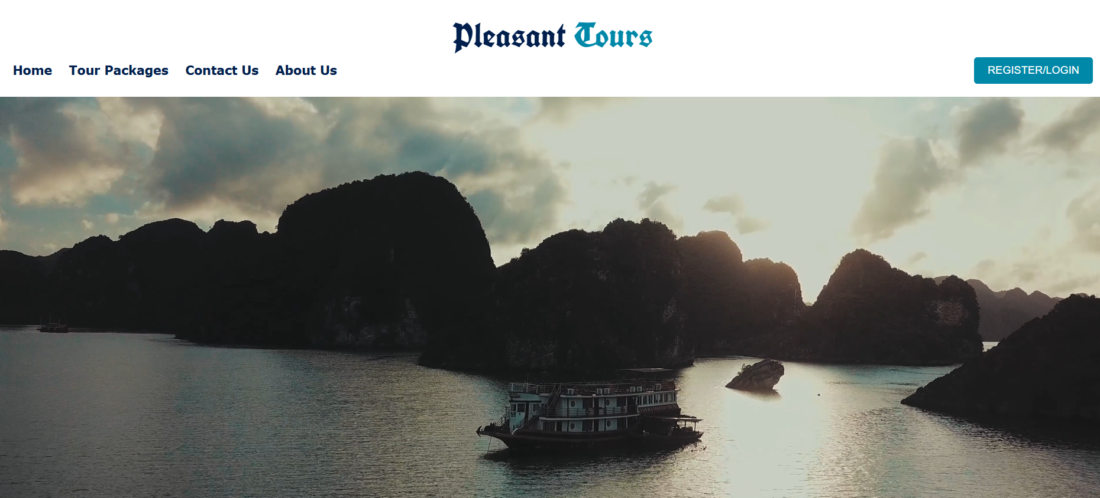

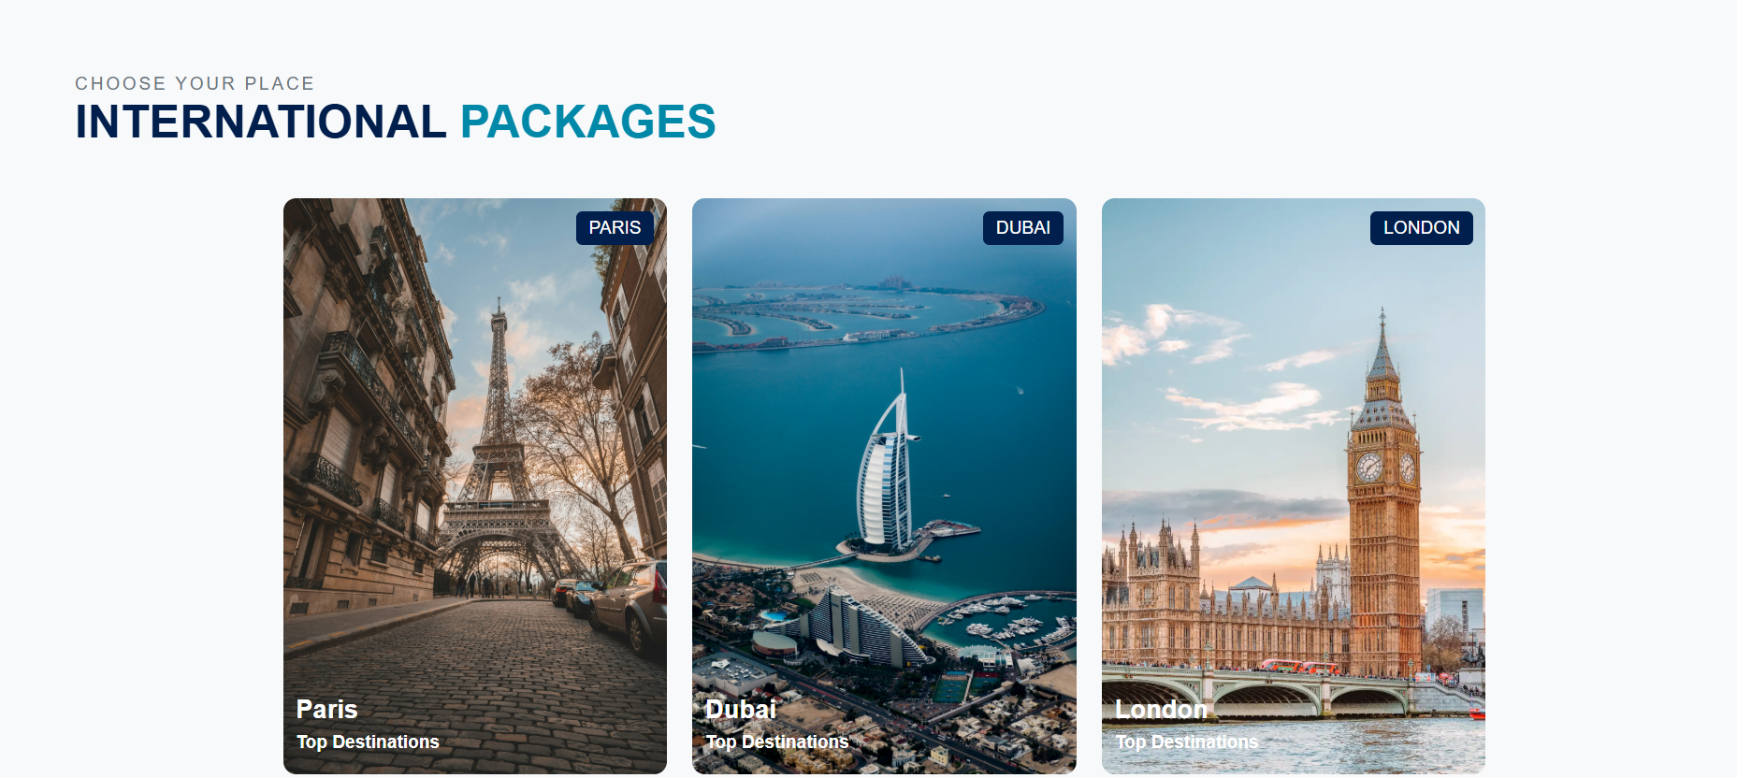

**Tour Pakages**

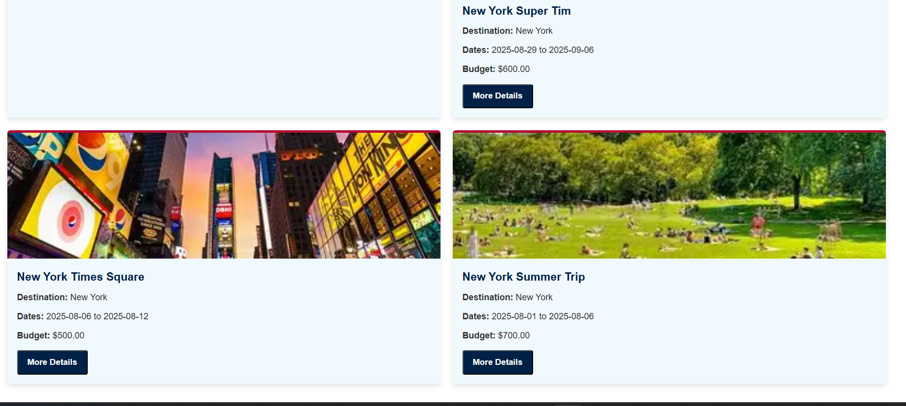

**Contact Us**

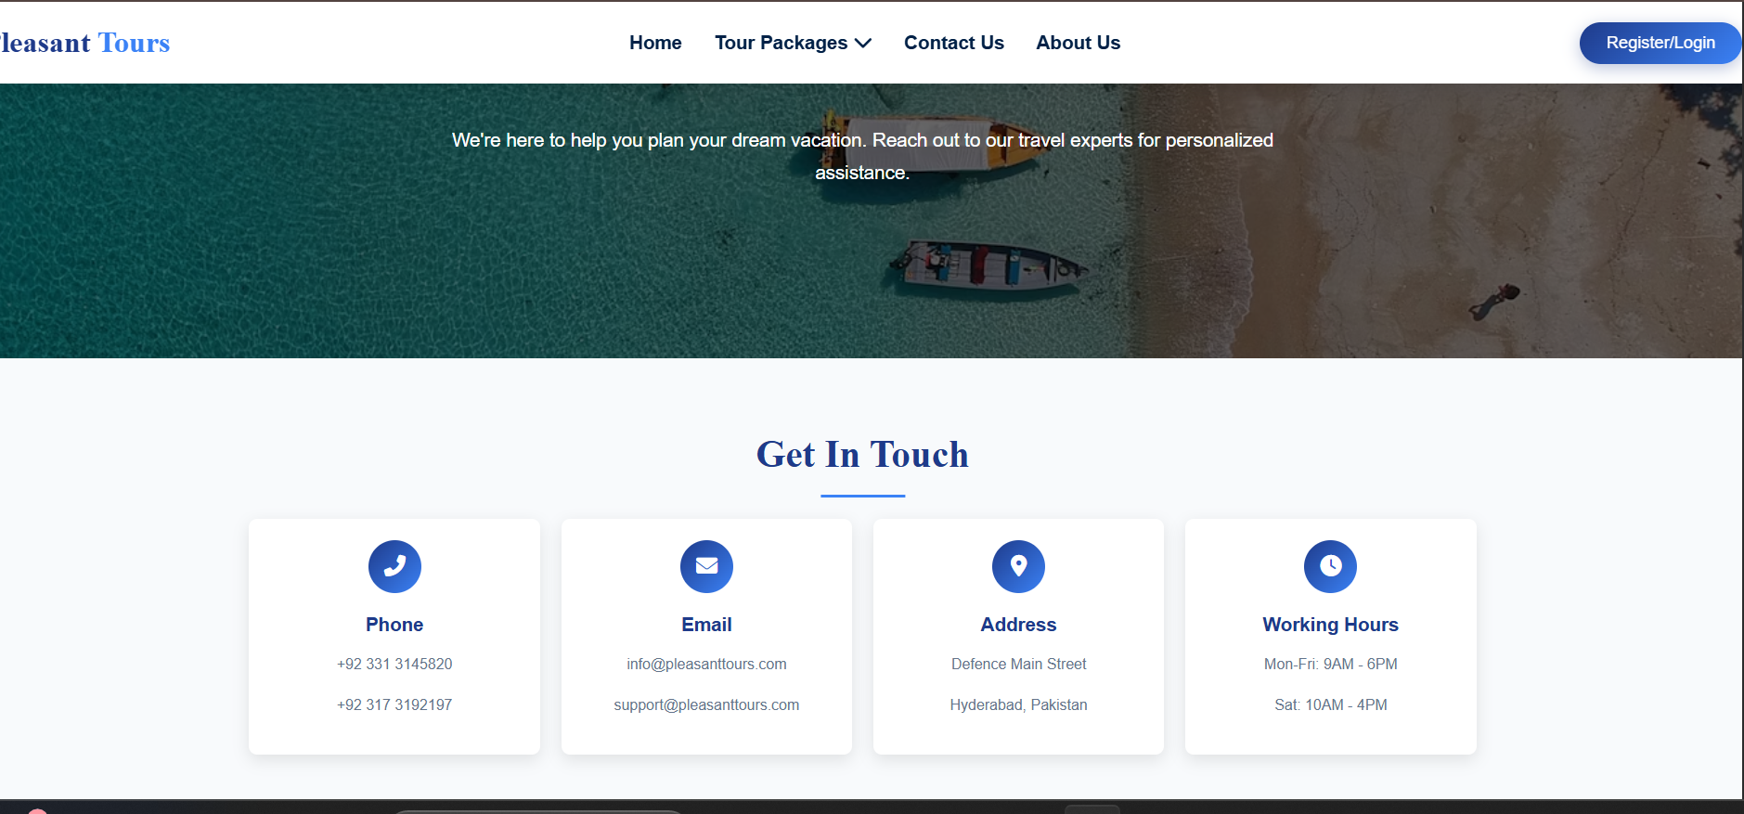

**About Us**



**THANNKS UH**

**THAT’S ALL ABOUT**

**REGARDS**

**MR AHMED SAMI**

**MR ABDUL HAYEE**

**MR HUZAIFA**

**HAS MADE THIS WEBSITE**

**CREDIT GOES TO RESPECTED SIR ABID**